Unit 4 Graded Exercise 3

The following questions come from the Check your understanding examples of each section of chapter 14 in your textbook.

After you are finished, please submit the Microsoft Word file that contains screenshots of the SQL script and the resulting tables. Your document should be named **U4_GradedExercise3_Lastname.docx**.

(14-3) Question 1:

The following *select* statement shows all the employees who are in each department. First run this code as it is—as an inner join. Then change it to a left outer join. What is the difference in the result tables?

*select a.department_name,*

*b.first_name,*

*b.last_name*

*from l_departments a,*

*l_employees b*

*where a.dept_code = b.dept_code;*

*yes, the results look different because it is an outer join and not an inner join.*

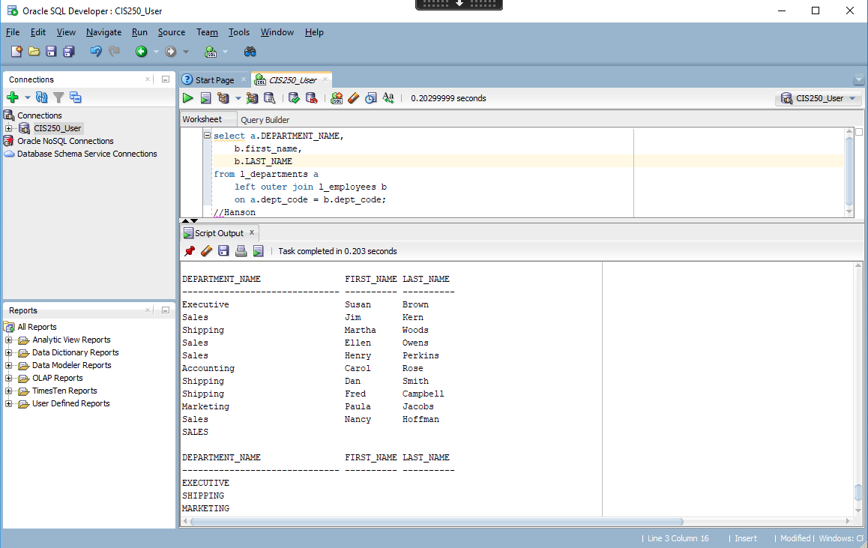

(14-4) Question 2:

This is a modification of the exercise in **section 14-3**. The only thing that has been changed is the order of the tables in the *from* clause. First run this code as it is—as an inner join. Then change this select statement to a right outer join. What is the difference in the result tables?

*select a.department_name,*

*b.first_name,*

*b.last_name*

*from l_employees b,*

*l_departments a*

*where a.dept_code = b.dept_code;*

*Both result tables look the same.*

(14-5) Question 3:

This is a modification of the exercise in **section 14-3**. The only thing that has changed is that table *sec1405_employees* replaces table *l_employees*. The new table contains one new employee who has not been assigned to any department yet. First run this code as it is—as an inner join. Then change this *select* statement to a full outer join. What is the difference in the result tables?

Where is the code? I could set it up If I knew what columns it wanted to use.

(14-7) Question 4:

The table *sec1407_departments* has the same format as the *l_departments* table. Write a *select* statement that shows the union of the two tables.

